1. 1. Write a program to rotate an object by 90 degree in clockwise direction

#include<graphics.h>

#include<stdio.h>

#include<conio.h>

#include<math.h>

int main()

{

int gd=DETECT,gm;

int pivot_x,pivot_y,x,y;

double degree,radian;

int rotated_point_x,rotated_point_y;

initgraph(&gd,&gm,"C://TURBOC3//BGI");

cleardevice();

printf("\n Enter an initial coordinates of the line = ");

scanf("%d %d",&pivot_x,&pivot_y);

printf("\n Enter a final coordinates of the line = ");

scanf("%d %d",&x,&y);

line(pivot_x,pivot_y,x,y);

printf("\n\n Enter a degree = ");

scanf("%lf",&degree);

radian=degree*0.01745;

rotated_point_x=(int)(pivot_x +((x-pivot_x)*cos(radian)-(y-pivot_y)*sin(radian)));

rotated_point_y=(int)(pivot_y +((x-pivot_x)*sin(radian)+(y-pivot_y)*cos(radian)));

setcolor(YELLOW);

line(pivot_x,pivot_y,rotated_point_x,rotated_point_y);

getch();

closegraph();

}

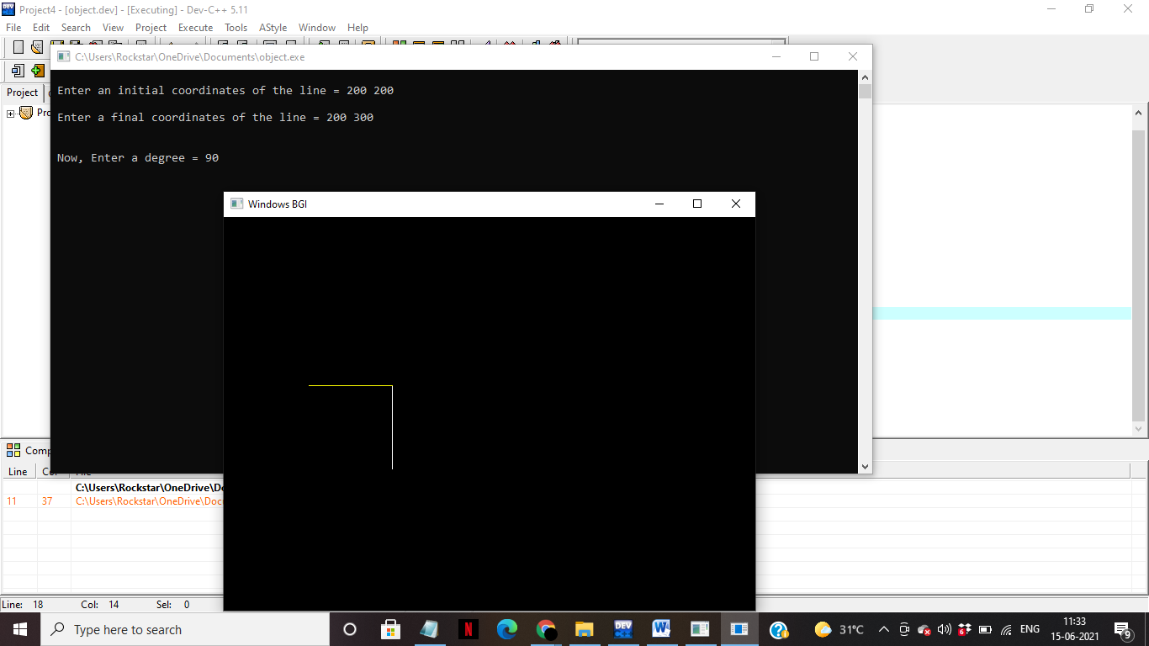

2.Write a program to draw a line using Bresenham’s line generation algorithm

#include<stdio.h>

#include<conio.h>

#include<graphics.h>

void drawline(int x1, int y1, int x2, int y2)

{

int dx, dy, p, x, y;

dx=x2-x1;

dy=y2-y1;

x=x1;

y=y1;

p=2*dy-dx;

while(x<x2)

{

if(p<0)

{

p=p+2*dy;

}

else

{

y=y+1;

p=p+2*dy-2*dx;

}

putpixel(x, y, BLUE);

x++;

}

}

int main()

{

int gd=DETECT, gm;

int x1, x2, y1, y2;

printf("Enter the starting and ending co-ordinates of the line\n");

scanf("%d %d %d %d",&x1, &y1, &x2, &y2);

initgraph(&gd, &gm, NULL);

drawline(x1, y1, x2, y2);

getch();

closegraph();

return 0;

}

OUTPUT:

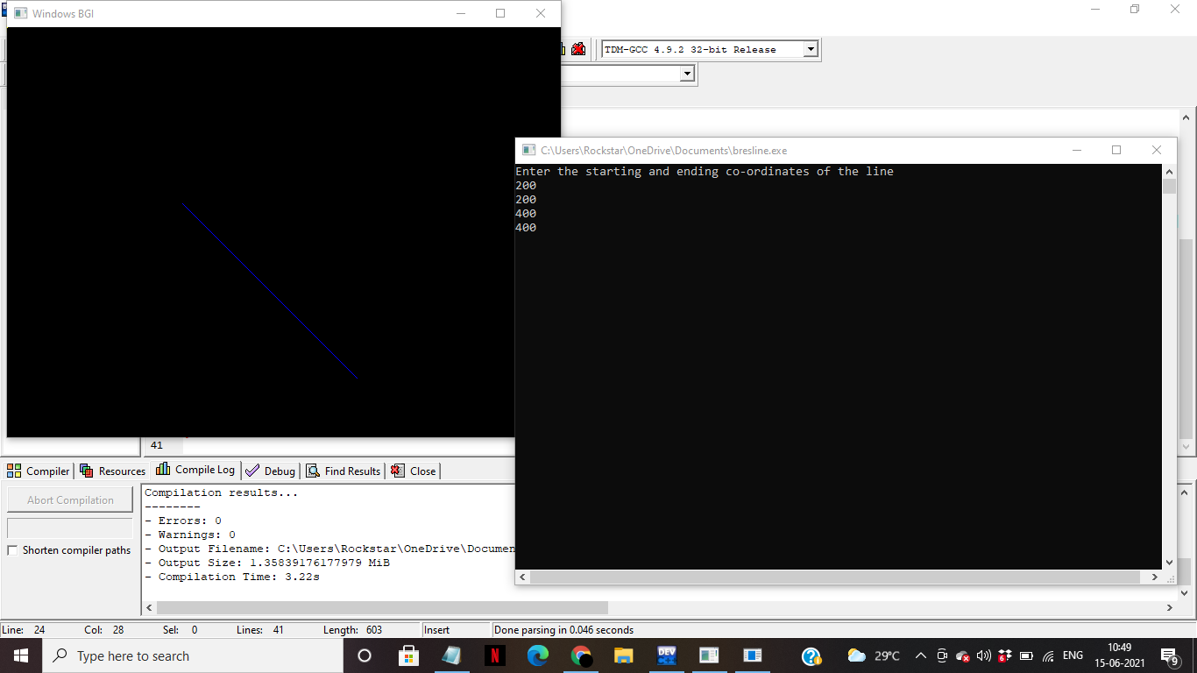

3.Write a program to implement Boundary-fill algorithm.

#include<stdio.h>

#include<graphics.h>

void boundary_fill(int x,int y,int boundary_fill,int fill_color);

int main()

{

int gd=DETECT,gm;

initgraph(&gd,&gm,"C://TurboC3//BGI");

int x,y,x1,x2,y1,y2;

printf("Enter top-left point of rectangle: ");

scanf("%d%d",&x1,&y1);

printf("Enter bottom-right point of rectangle: ");

scanf("%d%d",&x2,&y2);

cleardevice();

setcolor(WHITE);

rectangle(x1,y1,x2,y2);

boundary_fill(x1+1,y1+1,15,CYAN);

getch();

closegraph();

return 0;

}

void boundary_fill(int x,int y,int boundary_color,int fill_color)

{

int current;

current=getpixel(x,y);

if(current!=boundary_color && current!=fill_color)

{

putpixel(x,y,fill_color);

delay(10);

boundary_fill(x+1,y,boundary_color,fill_color);

boundary_fill(x,y+1,boundary_color,fill_color);

boundary_fill(x-1,y,boundary_color,fill_color);

boundary_fill(x,y-1,boundary_color,fill_color);

}

}

OUTPUT:

